Central Axis in Solid Geometry

Definition
# Source: AI Source: Provided by: [Data Path: Persons Table -> ID Column: 1, Name_En Column: Motasem Essam] -> From: [ChatGPT] on [7/25/2026]
A central axis is an imaginary straight line passing through the central region of a three-dimensional geometric solid, generally serving as a reference for describing its position, orientation, alignment, or rotational symmetry.
Depending on the solid, the central axis may pass through:
- The geometric center of the solid.
- The centers of its parallel circular or polygonal bases.
- The center of its rotational symmetry.
- The midpoint of its principal dimensions.
A central axis is particularly important in cylinders, cones, spheres, prisms, and other solids with rotational or axial symmetry.

Simple Definition
# Source: AI Source: Provided by: [Data Path: Persons Table -> ID Column: 1, Name_En Column: Motasem Essam] -> From: [ChatGPT] on [7/25/2026]
A central axis is an imaginary straight line passing through the center of a solid and used as a reference for describing its geometry and orientation.

Geometric Representation
# Source: AI Source: Provided by: [Data Path: Persons Table -> ID Column: 1, Name_En Column: Motasem Essam] -> From: [ChatGPT] on [7/25/2026]
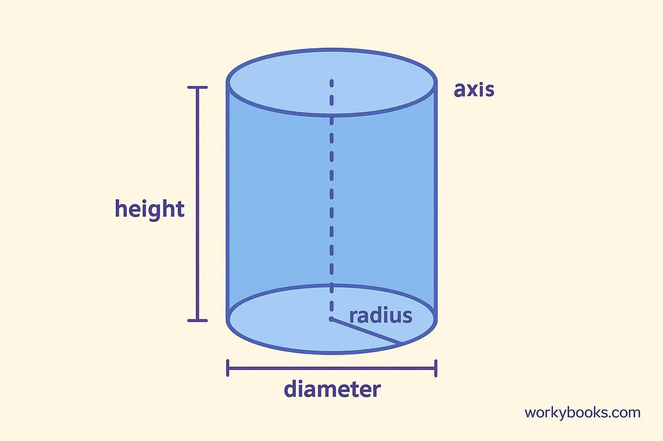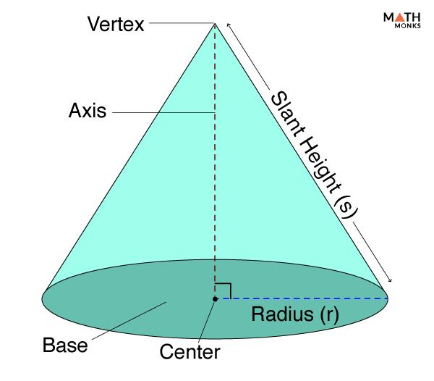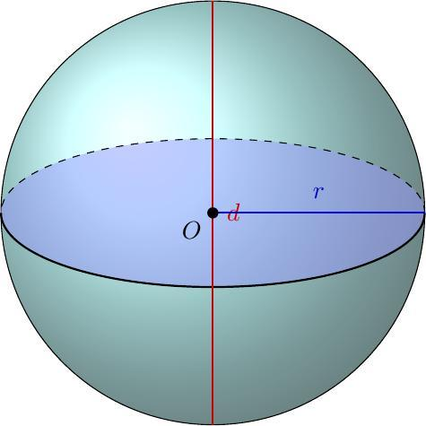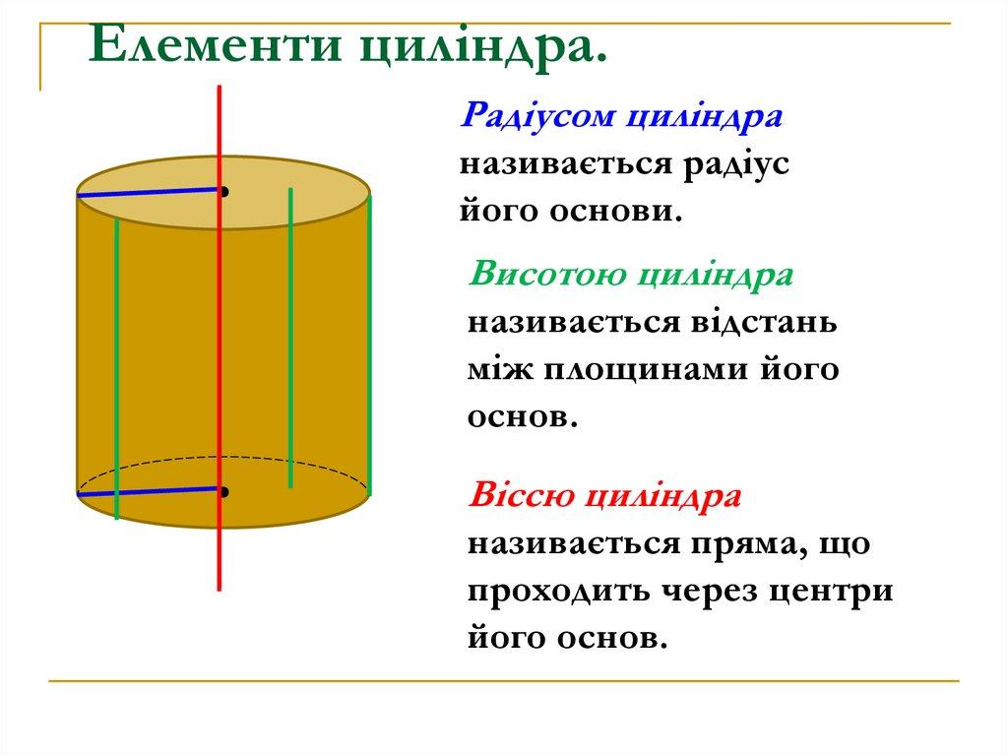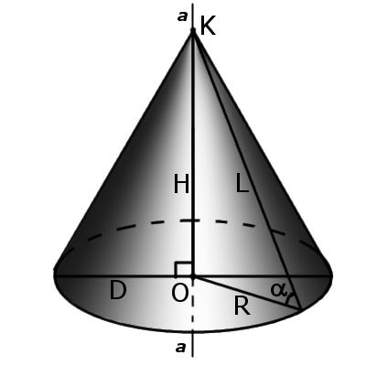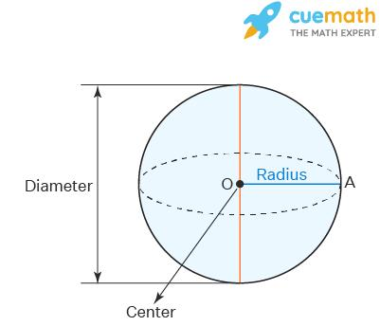
The central axis is represented by a straight reference line passing through the relevant central points of each solid.

Central Axis in Different Geometric Solids

Central Axis of a Cylinder
# Source: AI Source: Provided by: [Data Path: Persons Table -> ID Column: 1, Name_En Column: Motasem Essam] -> From: [ChatGPT] on [7/25/2026]
In a right circular cylinder, the central axis passes through the centers of the two circular bases and is perpendicular to both bases.
Characteristics:
- Passes through both base centers.
- Is perpendicular to the circular bases.
- Passes through the midpoint of the cylinder's height.
- Has the same direction as the cylinder's height.
For a cylinder of height $h$, the distance between the two base centers is:
$$d=h$$

Central Axis of a Cone
# Source: AI Source: Provided by: [Data Path: Persons Table -> ID Column: 1, Name_En Column: Motasem Essam] -> From: [ChatGPT] on [7/25/2026]
In a right circular cone, the central axis connects the apex to the center of the circular base.
Characteristics:
- Passes through the apex.
- Passes through the center of the circular base.
- Is perpendicular to the base plane.
- Coincides with the cone's altitude.
For cone height $h$:
$$Central Axis Length=h$$

Central Axis of a Sphere
# Source: AI Source: Provided by: [Data Path: Persons Table -> ID Column: 1, Name_En Column: Motasem Essam] -> From: [ChatGPT] on [7/25/2026]
In a sphere, a central axis is any straight line passing through its center.
Characteristics:
- Passes through the sphere's center.
- Extends through the sphere in both directions.
- Intersects the spherical surface at two antipodal points.
- Every diameter defines a possible central axis.
For a sphere of radius $r$:
$$Axis Segment Length=2r$$
A sphere has infinitely many possible central axes because every line through its center can serve as one.

Central Axis of a Hemisphere
# Source: AI Source: Provided by: [Data Path: Persons Table -> ID Column: 1, Name_En Column: Motasem Essam] -> From: [ChatGPT] on [7/25/2026]
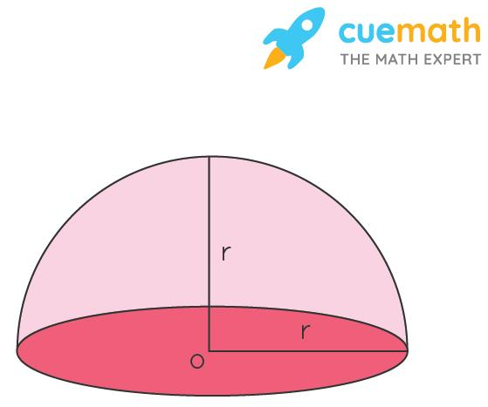
In a standard hemisphere, the central axis passes through the center of its circular base and the highest point of its curved surface.
Characteristics:
- Is perpendicular to the flat circular base.
- Passes through the center of the base.
- Coincides with the axis of rotational symmetry.
- Has a length equal to the hemisphere's radius from the base plane to the top.

Central Axis of a Prism
# Source: AI Source: Provided by: [Data Path: Persons Table -> ID Column: 1, Name_En Column: Motasem Essam] -> From: [ChatGPT] on [7/25/2026]
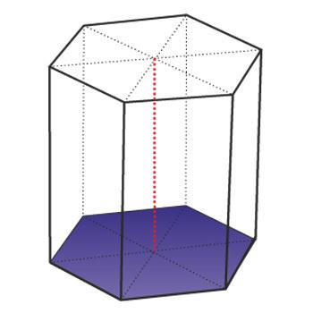
In a right regular prism, the central axis connects the centers of its two parallel bases.
Characteristics:
- Passes through the centers of the two bases.
- Is perpendicular to the base planes.
- Runs parallel to the lateral edges.
- Coincides with the prism's height direction.
For a right prism:
$$Central Axis Length=h$$
For an oblique prism, the line joining the base centers is not necessarily perpendicular to the base planes.

Central Axis of a Regular Pyramid
# Source: AI Source: Provided by: [Data Path: Persons Table -> ID Column: 1, Name_En Column: Motasem Essam] -> From: [ChatGPT] on [7/25/2026]
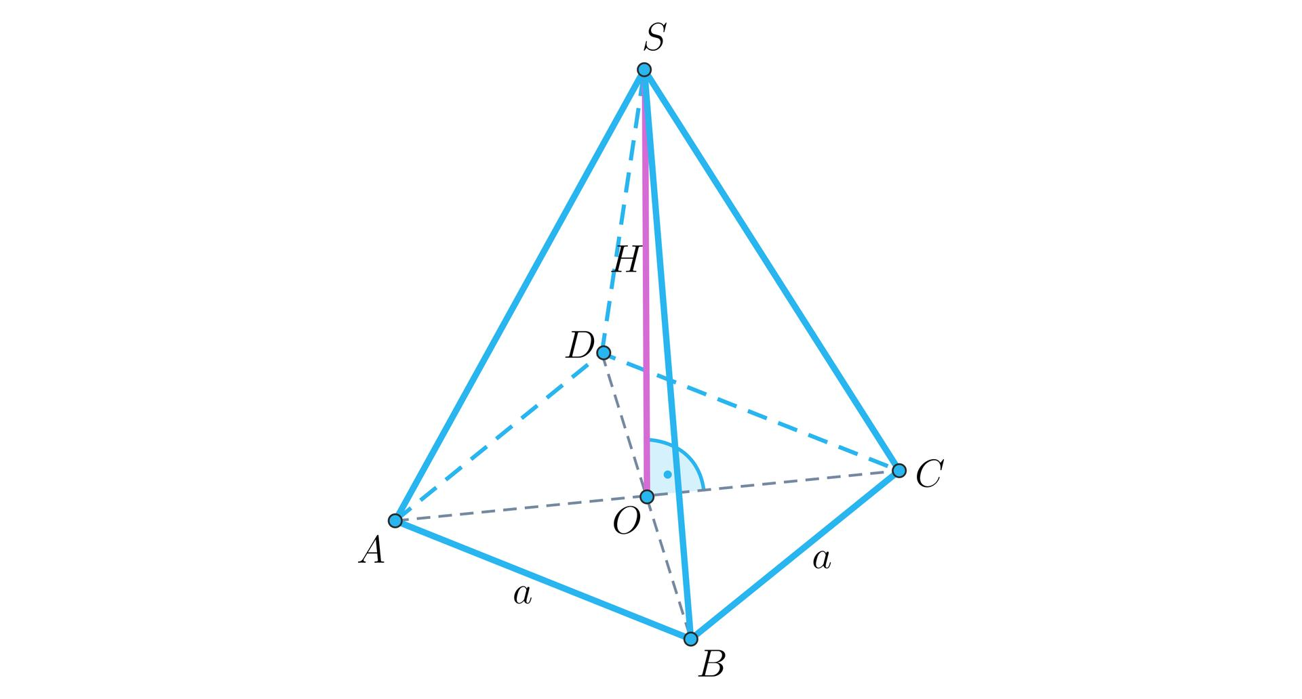
In a regular pyramid, the central axis connects the apex to the center of its regular polygonal base.
Characteristics:
- Passes through the apex.
- Passes through the center of the base.
- Is perpendicular to the base plane.
- Coincides with the pyramid's altitude.
For a regular pyramid:
$$Central Axis Length=h$$

Central Axis of a Torus
# Source: AI Source: Provided by: [Data Path: Persons Table -> ID Column: 1, Name_En Column: Motasem Essam] -> From: [ChatGPT] on [7/25/2026]
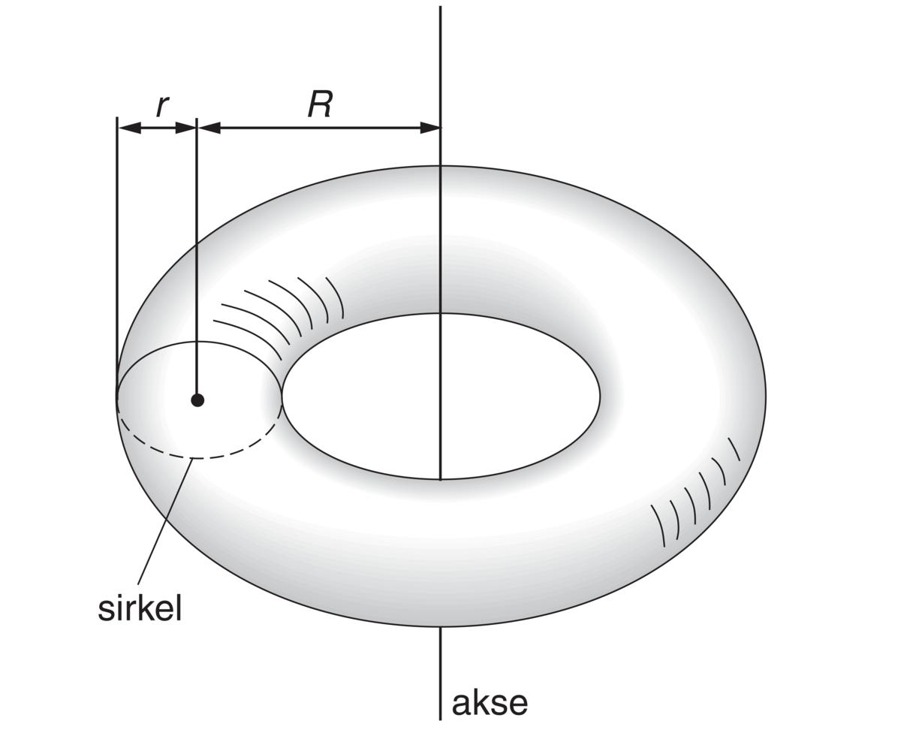
A torus has an axis of rotational symmetry passing through the center of its circular opening and perpendicular to the plane of the ring.
Characteristics:
- Passes through the center of the torus.
- Runs through the center of the circular opening.
- Is perpendicular to the plane containing the ring's central circular path.
- Defines the axis around which the generating circle revolves.

Classification of Central Axes

Vertical Central Axis
# Source: AI Source: Provided by: [Data Path: Persons Table -> ID Column: 1, Name_En Column: Motasem Essam] -> From: [ChatGPT] on [7/25/2026]

A central axis oriented vertically relative to a selected reference plane or coordinate system.

Horizontal Central Axis
# Source: AI Source: Provided by: [Data Path: Persons Table -> ID Column: 1, Name_En Column: Motasem Essam] -> From: [ChatGPT] on [7/25/2026]
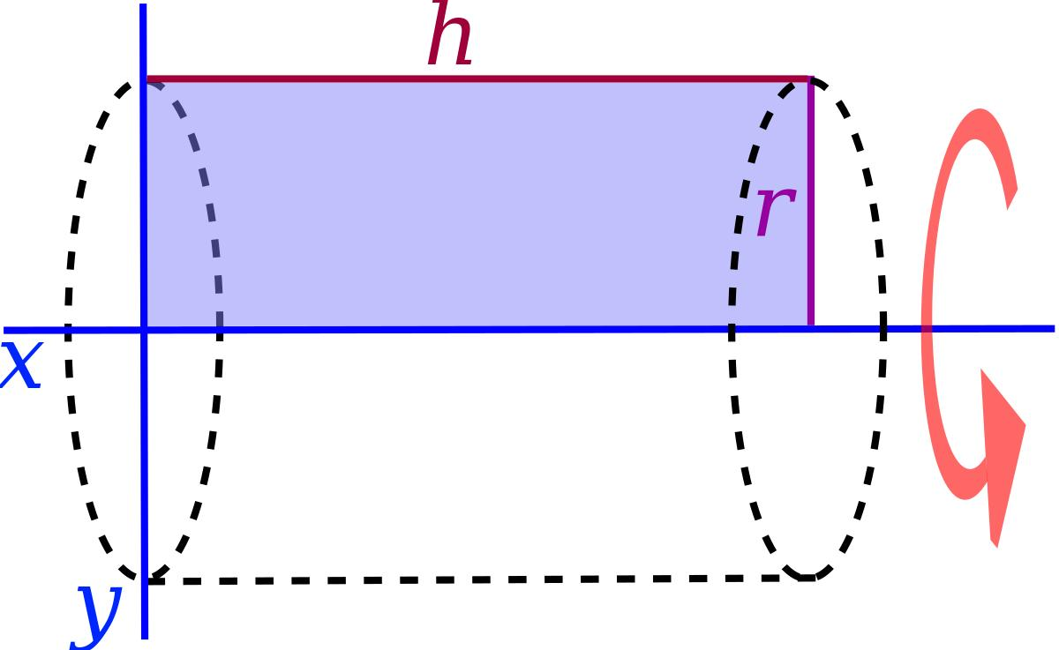
A central axis oriented horizontally relative to the selected reference plane.

Inclined Central Axis
# Source: AI Source: Provided by: [Data Path: Persons Table -> ID Column: 1, Name_En Column: Motasem Essam] -> From: [ChatGPT] on [7/25/2026]
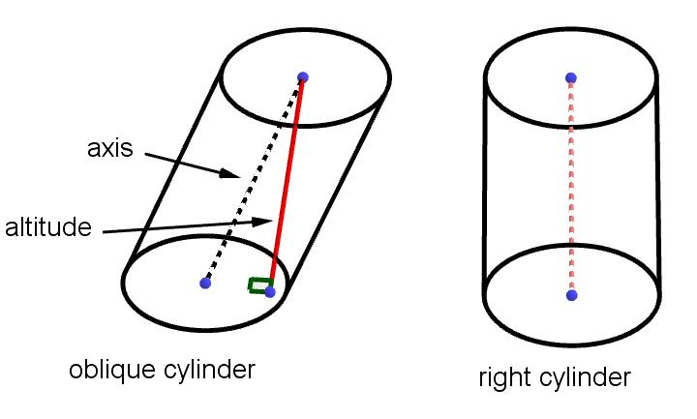
A central axis oriented at an angle to the horizontal and vertical reference directions.

Rotational Central Axis
# Source: AI Source: Provided by: [Data Path: Persons Table -> ID Column: 1, Name_En Column: Motasem Essam] -> From: [ChatGPT] on [7/25/2026]
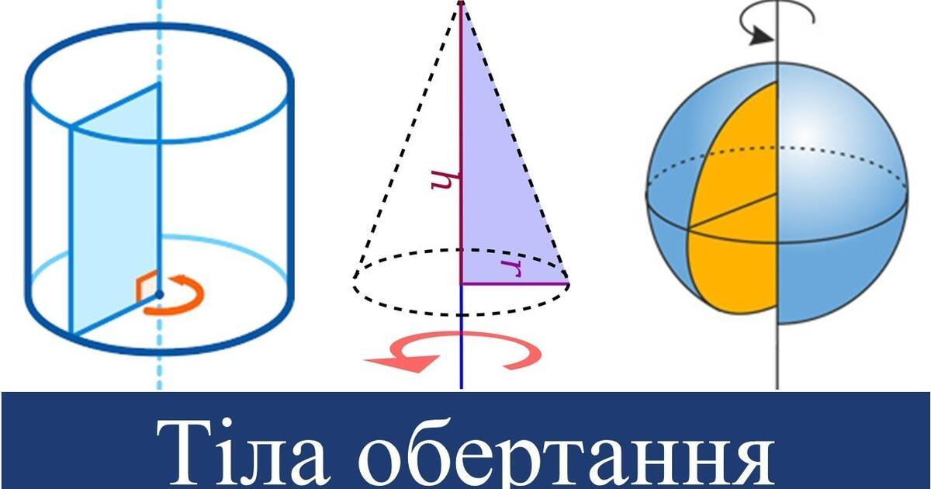
An axis around which a solid can be rotated through certain angles while preserving its geometric appearance.
Examples include:
- Cylinders.
- Cones.
- Spheres.
- Regular pyramids.
- Regular prisms.
- Tori.

Symmetry Central Axis
# Source: AI Source: Provided by: [Data Path: Persons Table -> ID Column: 1, Name_En Column: Motasem Essam] -> From: [ChatGPT] on [7/25/2026]
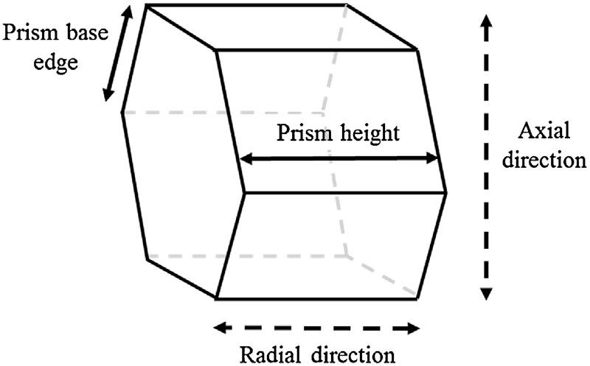
An axis associated with the symmetry of a solid, such that the solid has matching geometric features on corresponding sides of the axis.

Central Axis in Coordinate Geometry
# Source: AI Source: Provided by: [Data Path: Persons Table -> ID Column: 1, Name_En Column: Motasem Essam] -> From: [ChatGPT] on [7/25/2026]
A central axis can be represented using three-dimensional Cartesian coordinates.
For a vertical central axis passing through the point $(a,b)$, the equations are:
$$\boxed{x=a, y=b}$$
Here, $z$ varies along the axis.
For a horizontal axis parallel to the $x$-axis:
$$\boxed{y=b, z=c}$$
For an axis parallel to the $y$-axis:
$$\boxed{x=a, z=c}$$
A general line in three-dimensional space can be expressed parametrically as:
$$\boxed{beginalignedx\&=x_{0}+at\backslash y\&=y_{0}+bt\backslash z\&=z_{0}+ctendaligned}$$
Where:
- $(x_{0},y_{0},z_{0})$ is a point on the axis.
- $(a,b,c)$ is its direction vector.
- $t$ is a real parameter.

Central Axis and Rotational Symmetry
# Source: AI Source: Provided by: [Data Path: Persons Table -> ID Column: 1, Name_En Column: Motasem Essam] -> From: [ChatGPT] on [7/25/2026]
The central axis is closely related to rotational symmetry.
A solid has rotational symmetry about an axis if rotating it around that axis through certain angles produces an unchanged geometric appearance.
Examples:
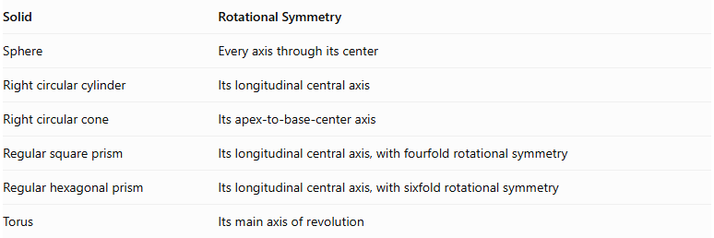
Solid | Rotational Symmetry
Sphere | Every axis through its center
Right circular cylinder | Its longitudinal central axis
Right circular cone | Its apex-to-base-center axis
Regular square prism | Its longitudinal central axis, with fourfold rotational symmetry
Regular hexagonal prism | Its longitudinal central axis, with sixfold rotational symmetry
Torus | Its main axis of revolution
For a solid with $n$-fold rotational symmetry, the smallest positive rotational angle that reproduces its appearance is:
$$\boxed{θ=\frac{{360}^{∘}}{n}}$$
For example, a regular hexagonal prism has:
$$θ=\frac{{360}^{∘}}{6}={60}^{∘}$$
Note: A circular cylinder has continuous rotational symmetry around its longitudinal axis, rather than a finite rotational order.

Central Axis in Composite Solids
# Source: AI Source: Provided by: [Data Path: Persons Table -> ID Column: 1, Name_En Column: Motasem Essam] -> From: [ChatGPT] on [7/25/2026]
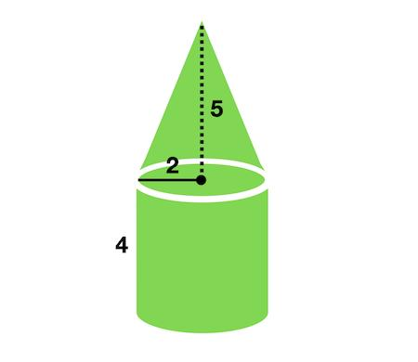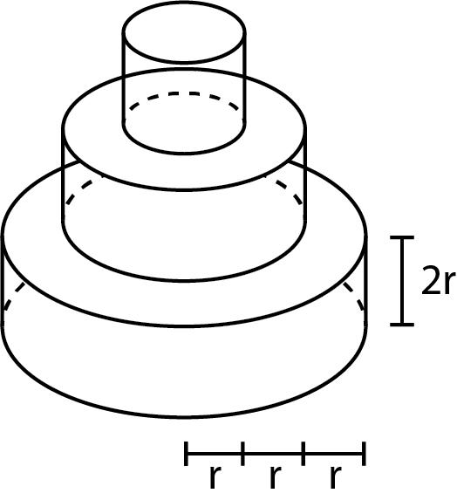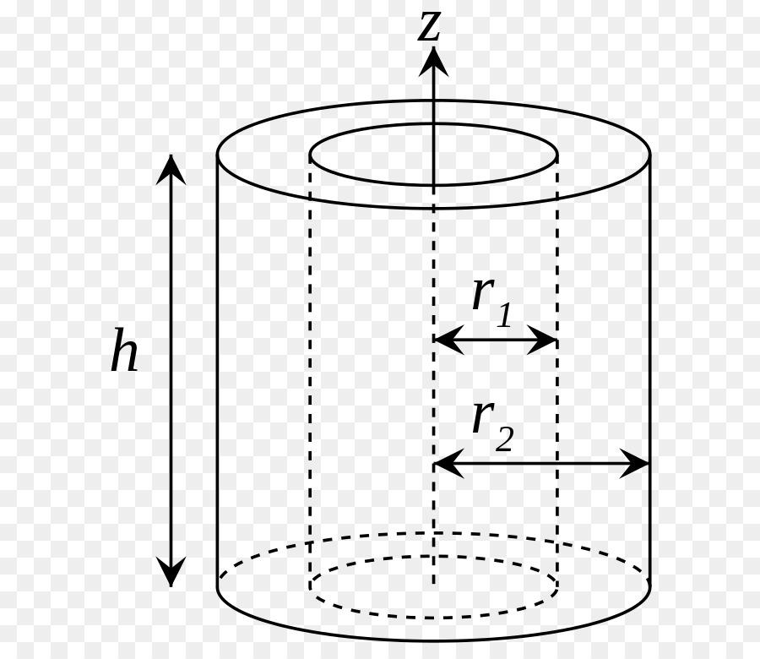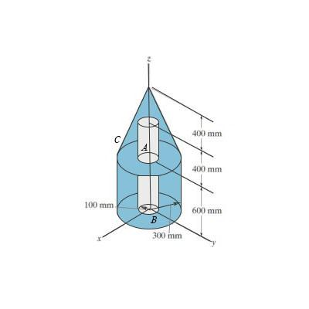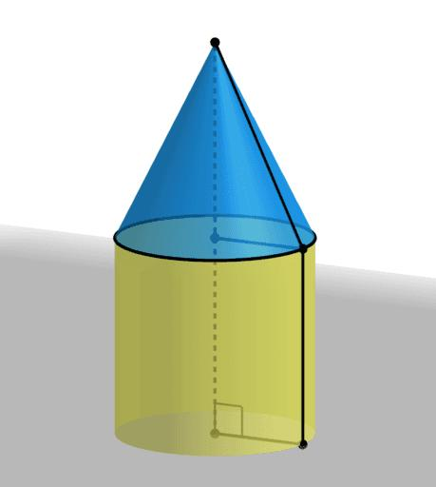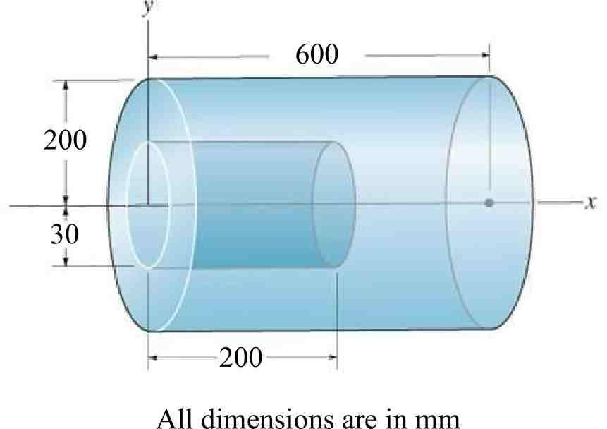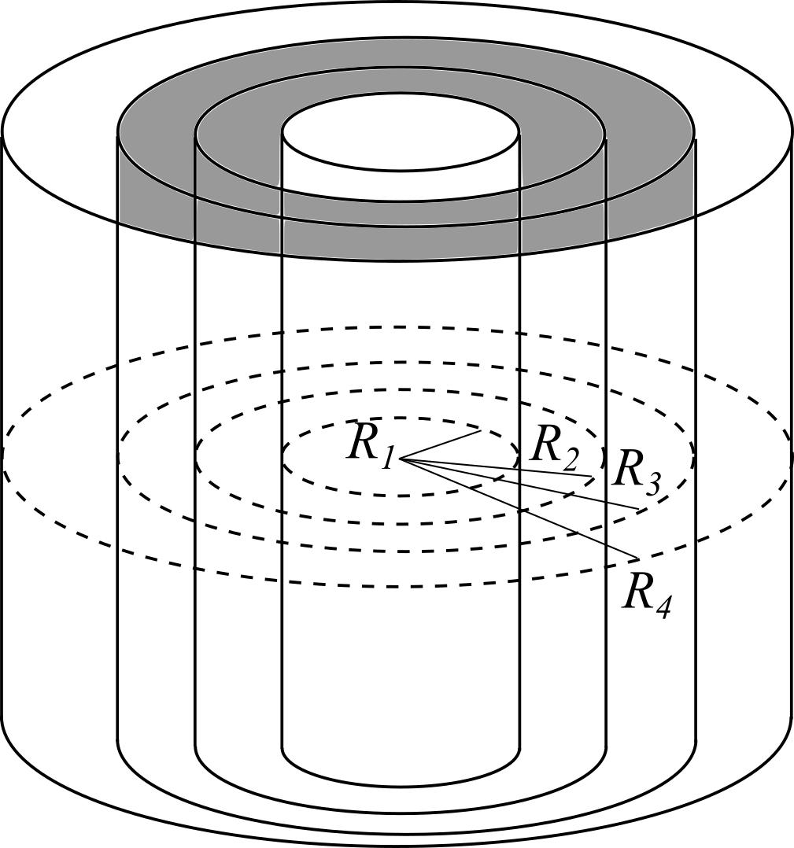
In composite solids, a central axis can serve as a common reference line for multiple components.

Common Central Axis
# Source: AI Source: Provided by: [Data Path: Persons Table -> ID Column: 1, Name_En Column: Motasem Essam] -> From: [ChatGPT] on [7/25/2026]
Multiple components share the same central axis.
Example: Two or more cylinders stacked vertically with their circular base centers aligned.

Coaxial Arrangement
# Source: AI Source: Provided by: [Data Path: Persons Table -> ID Column: 1, Name_En Column: Motasem Essam] -> From: [ChatGPT] on [7/25/2026]
Two or more cylindrical or rotational components have coincident axes.
Examples:
- Coaxial cylinders.
- Coaxial cones.
- Cylinder and cone sharing an axis.
- Concentric spherical or cylindrical structures.

Offset Central Axes
# Source: AI Source: Provided by: [Data Path: Persons Table -> ID Column: 1, Name_En Column: Motasem Essam] -> From: [ChatGPT] on [7/25/2026]
Components have parallel or differently oriented central axes that do not coincide.

Intersecting Central Axes
# Source: AI Source: Provided by: [Data Path: Persons Table -> ID Column: 1, Name_En Column: Motasem Essam] -> From: [ChatGPT] on [7/25/2026]
Two or more component axes cross at a common point.

Symmetrical Arrangement Around a Central Axis
# Source: AI Source: Provided by: [Data Path: Persons Table -> ID Column: 1, Name_En Column: Motasem Essam] -> From: [ChatGPT] on [7/25/2026]
Components are distributed around a common axis according to a symmetrical pattern.

Mathematical Properties

Distance Between Two Points on an Axis
# Source: AI Source: Provided by: [Data Path: Persons Table -> ID Column: 1, Name_En Column: Motasem Essam] -> From: [ChatGPT] on [7/25/2026]
For two points:
$$P_{1}=(x_{1},y_{1},z_{1})$$
$$P_{2}=(x_{2},y_{2},z_{2})$$
The distance is:
$$d=\sqrt{(x_{2}-x_{1})^{2}+(y_{2}-y_{1})^{2}+(z_{2}-z_{1})^{2}}$$

Midpoint of an Axis Segment
# Source: AI Source: Provided by: [Data Path: Persons Table -> ID Column: 1, Name_En Column: Motasem Essam] -> From: [ChatGPT] on [7/25/2026]
$$M=(\frac{x_{1}+x_{2}}{2},\frac{y_{1}+y_{2}}{2},\frac{z_{1}+z_{2}}{2})$$

Angle Between Two Axes
# Source: AI Source: Provided by: [Data Path: Persons Table -> ID Column: 1, Name_En Column: Motasem Essam] -> From: [ChatGPT] on [7/25/2026]
For direction vectors:
$$vecu=(a_{1},b_{1},c_{1})$$
$$vecv=(a_{2},b_{2},c_{2})$$
The angle between them is:
$$\boxed{cosθ=\frac{vecu·vecv}{|vecu||vecv|}}$$

Distance from a Point to an Axis
# Source: AI Source: Provided by: [Data Path: Persons Table -> ID Column: 1, Name_En Column: Motasem Essam] -> From: [ChatGPT] on [7/25/2026]
For a line passing through point $A$, with direction vector $vecd$, and a point $P$:
$$\boxed{D=\frac{|overrightarrowAP×vecd|}{|vecd|}}$$
This formula calculates the shortest perpendicular distance from the point to the axis.

Worked Examples

Example 1: Central Axis of a Cylinder
# Source: AI Source: Provided by: [Data Path: Persons Table -> ID Column: 1, Name_En Column: Motasem Essam] -> From: [ChatGPT] on [7/25/2026]
Given:
A right circular cylinder has:
- Radius: $r=4 cm$.
- Height: $h=12 cm$.
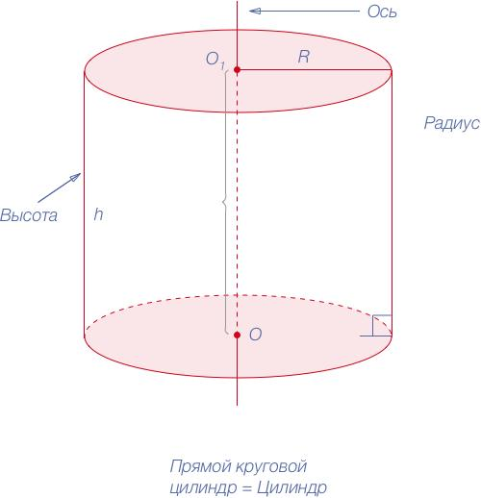
Step 1: Identify the central axis.
The central axis connects the centers of the two circular bases.
Step 2: Calculate the axis length.
$$L=h$$
$$\boxed{L=12 cm}$$
Step 3: Calculate the distance from the axis to the curved surface.
This distance is the cylinder's radius:
$$\boxed{d=4 cm}$$
Result:
- Central axis length = 12 cm.
- Distance from the central axis to the curved surface = 4 cm.

Example 2: Angle Between Two Central Axes
# Source: AI Source: Provided by: [Data Path: Persons Table -> ID Column: 1, Name_En Column: Motasem Essam] -> From: [ChatGPT] on [7/25/2026]
Given:
Two central axes have direction vectors:
$$vecu=(1,0,0)$$
$$vecv=(0,1,1)$$
Step 1: Calculate their dot product.
$$vecu·vecv=(1)(0)+(0)(1)+(0)(1)=0$$
Step 2: Calculate their magnitudes.
$$|vecu|=1$$
$$|vecv|=\sqrt{0^{2}+1^{2}+1^{2}}=\sqrt{2}$$
Step 3: Calculate the angle.
$$cosθ=\frac{0}{1·\sqrt{2}}=0$$
$$\boxed{θ={90}^{∘}}$$
The two axes are perpendicular.

Important Characteristics
# Source: AI Source: Provided by: [Data Path: Persons Table -> ID Column: 1, Name_En Column: Motasem Essam] -> From: [ChatGPT] on [7/25/2026]
- Imaginary reference line: A central axis is a geometric reference, not a physical edge or surface.
- Passes through a central region: It passes through the relevant center or central points of a solid.
- Defines orientation: It helps describe the direction in which a solid is positioned.
- Supports symmetry analysis: It identifies axes associated with rotational or other geometric symmetry.
- Useful for alignment: It helps determine whether multiple components share the same axis.
- May be unique or non-unique: Some solids have one principal central axis, while others have infinitely many possible central axes.
- Can be vertical, horizontal, or inclined: Its orientation depends on the selected coordinate system.
- Important in composite geometry: It helps describe coaxial and symmetrical arrangements.

Comparison with Related Geometric Terms
# Source: AI Source: Provided by: [Data Path: Persons Table -> ID Column: 1, Name_En Column: Motasem Essam] -> From: [ChatGPT] on [7/25/2026]
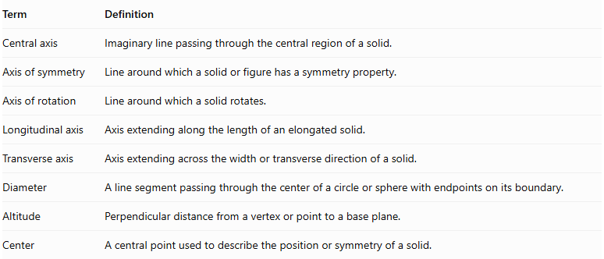
Term | Definition
Central axis | Imaginary line passing through the central region of a solid.
Axis of symmetry | Line around which a solid or figure has a symmetry property.
Axis of rotation | Line around which a solid rotates.
Longitudinal axis | Axis extending along the length of an elongated solid.
Transverse axis | Axis extending across the width or transverse direction of a solid.
Diameter | A line segment passing through the center of a circle or sphere with endpoints on its boundary.
Altitude | Perpendicular distance from a vertex or point to a base plane.
Center | A central point used to describe the position or symmetry of a solid.
Important distinction: A central axis is not necessarily the only axis of symmetry. A sphere, for example, has infinitely many axes passing through its center.

Applications
# Source: AI Source: Provided by: [Data Path: Persons Table -> ID Column: 1, Name_En Column: Motasem Essam] -> From: [ChatGPT] on [7/25/2026]
- Architecture: Establishing central alignment in columns, towers, and symmetrical structures.
- Mechanical engineering: Aligning shafts, gears, bearings, and rotating components.
- Construction: Positioning cylindrical columns and other structural elements.
- Manufacturing: Defining rotation and machining axes.
- Mathematics: Studying solid symmetry, coordinate geometry, and spatial relationships.
- Composite-solid geometry: Identifying common axes in stacked and coaxial components.

Key Points
# Source: AI Source: Provided by: [Data Path: Persons Table -> ID Column: 1, Name_En Column: Motasem Essam] -> From: [ChatGPT] on [7/25/2026]
- A central axis is an imaginary straight reference line through the central region of a solid.
- Its position and orientation depend on the geometry of the solid.
- In a right circular cylinder, it connects the centers of the two circular bases.
- In a right circular cone, it connects the apex to the center of the base.
- In a sphere, every line through the center can serve as a central axis.
- Multiple components can share a common central axis.
- Central axes are important for studying alignment, rotational symmetry, and composite solids.

Conclusion
# Source: AI Source: Provided by: [Data Path: Persons Table -> ID Column: 1, Name_En Column: Motasem Essam] -> From: [ChatGPT] on [7/25/2026]
The central axis is an important geometric reference used to describe the orientation, central alignment, and symmetry of three-dimensional solids. It is especially useful in rotational solids such as cylinders, cones, spheres, and tori, as well as in composite solids formed by combining multiple components. Understanding the central axis provides a foundation for studying coaxial arrangements, rotational symmetry, and spatial relationships between geometric solids.

